Homework Assignment 1

**1.Work *Example 3-3* on Amazon Elastic MapReduce. Type out all the commands in each step of the process and print out a screenshot of the final results in Amazon EMR.**

**Answer**:

**Step 1: Compile the Java file**

javac -cp src/:hadoop-common-2.6.1.jar:hadoop-mapreduce-client-core-2.6.1.jar:commons-cli-2.0.jar -d . FileSystemDoubleCat.java

**Step 2: Make a input directory and copy the quangle file there.**

hdfs dfs -mkdir /user/hadoop/Example3.1_Input/

hdfs dfs -copyFromLocal quangle.txt /user/hadoop/Example3.1_Input

Screenshot

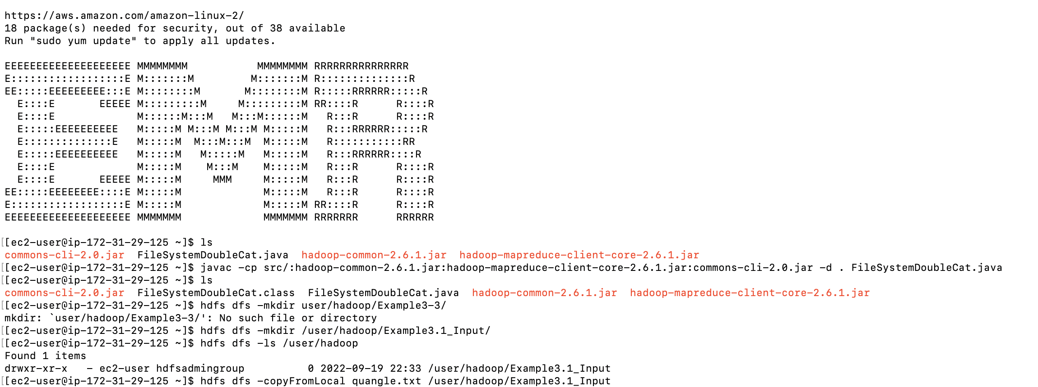

**Step 3: Execute the file to see Double output.**

hadoop FileSystemDoubleCat hdfs:///user/hadoop/Example3.1_Input/quangle.txt

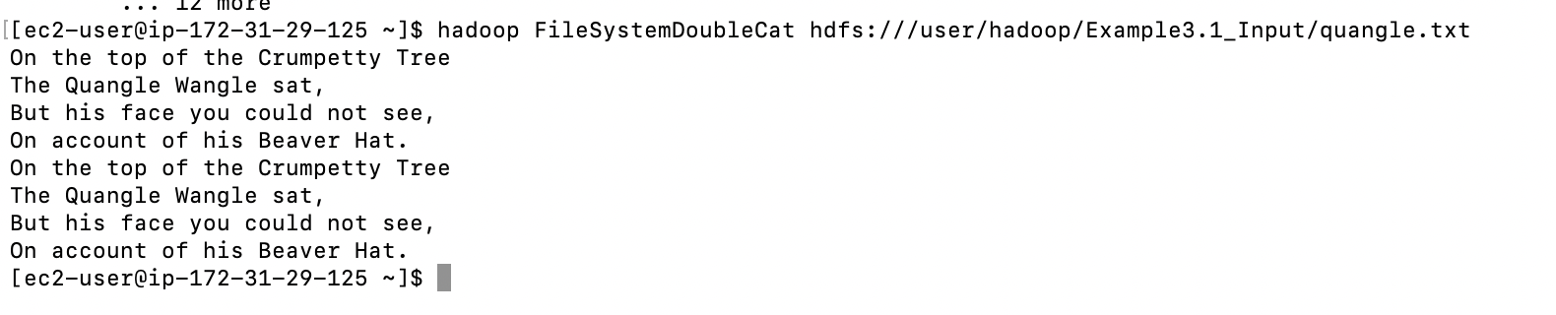

**2.Work *Example 3-4* on Amazon Elastic MapReduce. Type out all the commands in each step of the process and print out a screenshot of the results (showing the file directory) in Amazon EMR.**

**Answer**

**Step 1: Making a directory in HDFS file system for example 3.4**

**Step 2: Compiling the java file**



**Step 3: Execute the FileCopyWithProgress and show output in the Directory**

